New Starfish Flag for Online Learning!

We have developed a new flag that will allow you to identify students who are not “active” in your online courses. Now that taking attendance is no longer relevant for this semester, this new flag can be used when you know a student has not accessed or logged into your course in a manner that is required for active participation and success.
The flag is called “Not Active in Course”. It can be raised by only the course instructor and will be viewable to the student and their support networks. We want you to use this flag to help us identify students who have possibly “checked-out” or may have “connectivity issues”.
If the student is accessing the course, but not submitting work, participating in discussions or performing poorly on tests or quizzes please continue to use our tradition academic alert flags like “Missing Work” or “Low Grades”.
The CACS team will be monitoring these flags and responding in different ways to different flags. If the “Not Active in Course” flag is raised it will prompt immediate outreach. If any of the other academic flags are raised, outreach will be trigger when the student hits 3 or more flags, unless the student is already on someone’s program caseload (HEOP, TRIO, ARP, Transitional).
To determine if a student is active, you can see their last date of course activity under the “people” section of your course in canvas:
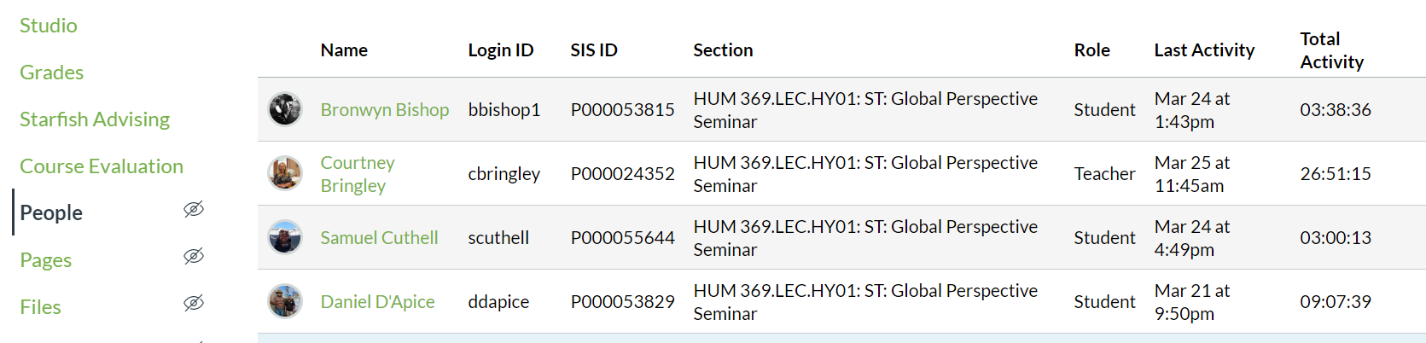

You can and should use your judgement about what level of activity is required for your course, however, at a very minimum the student should be active in your course at least once a week.
To raise the flag simply find the student in Starfish and click to add a flag:

