Cassidy Smith
Paul Smith’s College IT Department
Information Technology Reference Guide

Description: Information technology is a field that changes daily and without warning. Your education could be relevant today and the next, your education is now considered out-of-date. Luckily within the fast pace world of technology, lies industry standards, procedures, and end-user understanding. If an individual wishes to maintain control over the rapid pace of technology, then he or she must master these ideologies. The purpose of this document is to provide those fundamental tools and provide basic understanding of information technology.

This document has been created with the assumption that the reader’s background in IT ranges from entry level through intermediate. Individuals who would benefit greatly from this guide include, but certainly not limited to the following:
- IT Workstudy (Tier 1)
- IT Workstudy Manager (Tier 1.5)
- IT Helpdesk Manager
- Tier 2 PC Technician

This document will cover the foundations of IT including, but not limited to the following:
- Basic Understanding of a PC (Hardware, Software, & Operating System(s))
- Basic Understanding of a Network
- Basic Understanding of Systems
- Basic Understanding of End-User Devices
- Basic Understanding of IT Troubleshooting & Customer Relationships

Table of Contents

Part 1: Overview of Information Technology 3
Part 2: Basics of a PC 6
Overview 6
Hardware 6
Software 10
Operating System 13
Part 3: Basics of a Network 17
Overview 17
Network (Device Checklist) 18
Network (Segments) 21
Network (Equipment) 22
Part 4: Basics of a System 26
Overview 26
System (Servers) 26
Part 5: Basics of End-User Devices 33
Overview 33
End-User Devices (Examples) 33
Part 6: Basics of Troubleshooting 36
Overview 36
Troubleshooting (OSI Layer) 36
Troubleshooting (Proper Information Gathering) 37
Troubleshooting (Customer Service) 42
Part 7: Review Questions 44

Part 1: Overview of Information Technology

In the world of information technology, one must understand the full enbodiment of what is in place within the organization. Like a human body, we need all of our organs to work as one unit in order to survive. Without the brain, heart, lungs, and/or other vital organs, the body will slowly cease to function. With this analogy in mind, we must look at information technology within an organization the same way. Think of IT professionals as technology surgeons, doctors, and nurses. It is our job to ensure that the IT body of the organization is healthy, and providing excellent service for those who utilize it every day. If a part of the IT body becomes sick, it is our job to observe the symptoms, analyze possible solutions based on our observations, and initiate a plan of attack to correct the problem.

Now that we have compared the IT body to the human body, we need to determine what the IT body’s vital organs are as well. Below is a breakdown on those pieces:

- Basics of a PC
  - Hardware
  - Software
  - Operating System
- Basics of a Network
  - IP Address
  - Subnet Mask
  - Default Gateway
  - MAC Address
  - LAN
  - WAN
  - WLAN
  - VLAN
  - Wifi
    - SSID
  - Network Equipment
    - Switches
    - Cord Types
    - Firewall
    - Modem
    - Ports (Physical)
- Basics of a System
  - DHCP
  - FTP
  - DNS
  - Active Directory
  - Print
  - Ports (Non-Physical)
  - VOIP
  - Network Controller
- Basics of End-User Devices
  - Printers
  - VOIP Phones
  - Laptops
  - Desktops
  - Mobile Devices
  - Tablets
- Basics of Troubleshooting
  - OSI Layer
  - Proper Information Gathering
  - Customer Service
    - E-mail
    - Walk-Ins
    - Phone

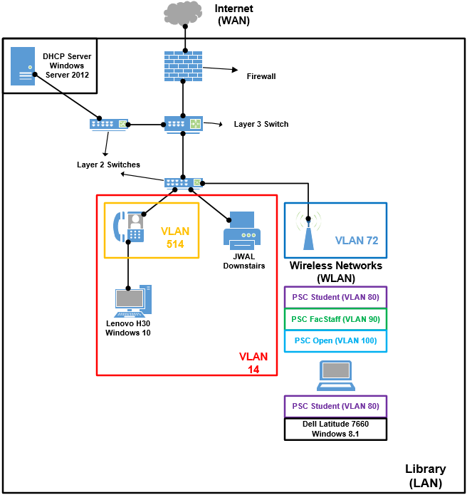
Figure 1 shows just a small snapshot on all of the different pieces of information technology working together as one IT body. Before we break it down, let’s zoom in on these vital pieces. From a student’s laptop perspective, we need to connect to the wireless network in order to go to www.google.com. How do we do that? Let’s follow the full path below:
- First, we need the help of a wireless access point to connect to.
- Next, we need to determine which wireless network best fits our needs. At this time, PSC Student is the best wireless network for us to connect to.
Figure 1 - Snapshot of PSC's Information Technology
- Now, our Windows Operating System will need to obtain an IP address from our DHCP server in order to connect to the network.
- Once we are connected, our information needs to be passed through the wireless access point, and onto the next connection.
- From the wireless access point, our connection is passed to our Layer 3 switch to then be handed off once again.
- Now, our information is sent to our firewall to be analyzed before being sent out into the Internet.
For now, these steps may sound confusing, but we will cover each vital piece as we continue through this guide. As you can see, each piece is vital in order for the laptop to simply go to www.google.com on the Internet. With this guide, you will be able to analyze the symptoms of each piece as well as providing solutions to bring the IT body back in tip top shape. Let’s begin with the basics of a PC.

Part 2: Basics of a PC

Overview
In most organizations, end-user devices like PCs (personal computers) are an essential tool used to complete tasks, organize work, and have a productive work environment. For IT professionals, it is important to understand the three core pieces in most end-user devices: hardware, software, and operating systems. Let’s break down each piece, describe some examples, and why they are needed.

Hardware
Hardware are all of the physical pieces that allows for proper use of a PC. For example, the keyboard that I am using right now to type this document could be considered as hardware in a laptop. Another example would be the hard disk storage used to save this document so I can make any changes in the future after the PC is turned off. Now that we listed a few brief examples, let’s list the most common hardware pieces you will encounter:

Hardware | Description | Example
Random Access Memory (RAM) | The location in a computer where the operating system, programs, currently used data are kept for quicker access by the CPU. An example would be like a workbench in your garage. It is much easier/faster for the user to grab the tools on the workbench as opposed to going outside, in the shed, grab the tool, and come back inside the garage. However, once the device is turned off, all data stored in RAM is gone. | 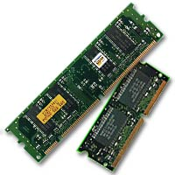
Hard Disk Drive (HDD) | The mechanism that controls the location, reading, and writing of the hard disk which is what provides data storage for the PC. An example would be like writing down notes from a lecture. You are writing or storing the information that you are obtaining from a teacher to recall at a later time. Once a device is off, the data will remain on the drive. | 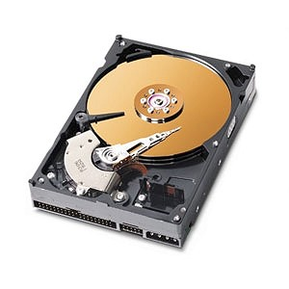
Motherboard | A circuit board containing the principle components of a PC with available connections where other boards can be inserted. An example would be like a base model car. If you wanted to add new features, your car would have to have the ability (connectors), to take on the new feature. | 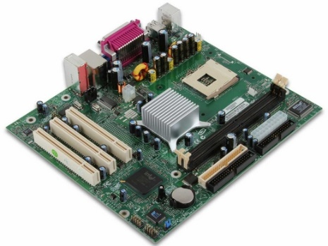
Central Processing Unit (CPU) | The brains of the PC where the majority of calculations occur. | 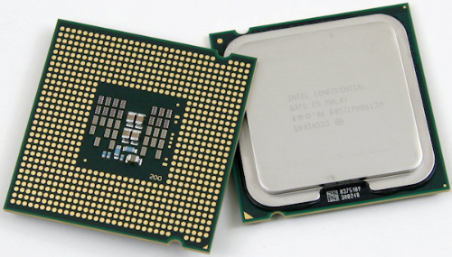
Power Supply | A unit or battery that provides power to the PC. | 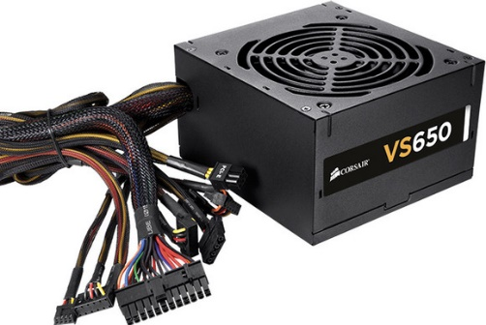
Graphics Card (optional) | An addition to provide more resources for labor intensive, visual programs such as games. These are often not required, but it provides the PC more resources to work with to get the current job done. | 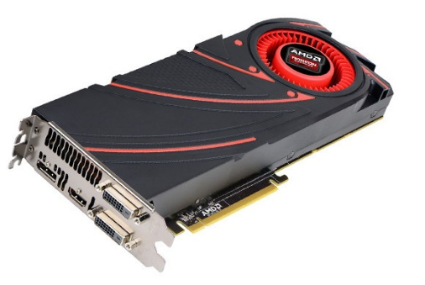
Heatsink | A unit that absorbs and properly distributes excessive or unwanted heat. An example of this would be like a person sweating. If you are getting too hot, your body attempts to cool you down by sweating which absorbs the heat much more efficiently. | 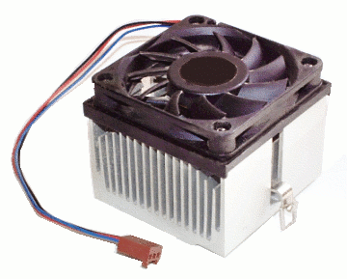
Network Interface Card (NIC) | A component that provides the PC network access. This can either be a wired or a wireless connection. Without it, the PC cannot communicate with other devices over normal means. | 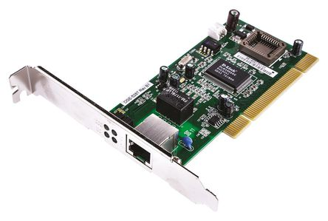
Universal Serial Bus (USB) | Industry standard that defines cables, connectors, and communication protocols used in a bus connection, communication, and power supply between the PC and the device. Common standards include USB 2.0 and USB 3.0 (marked with a blue end). | 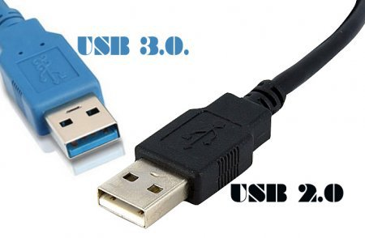
Video Graphic Array (VGA) | Type of video graphics connection. This cable can only provide video and NOT audio. The resolution is dependant on the video card used to connect the cable. In this example, both the male (right side) and female (left side) connections are present. | 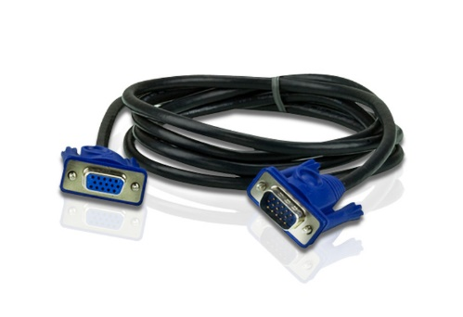
Digital Visual Interface (DVI) | Type of video graphics connection. This cable can only provide video and NOT audio. The resolution is dependant on the video card used to connect the cable. In this example, both the male (left side) and female side (right side) connections are present. | 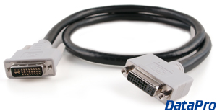
High-Definition Multimedia Interface (HDMI) | Type of video and audio connection. This cable can provide video AND audio. The resolution is dependant on the video card used to connect the cable. In this example, both the male (right side) and female (left side) connections are present. | 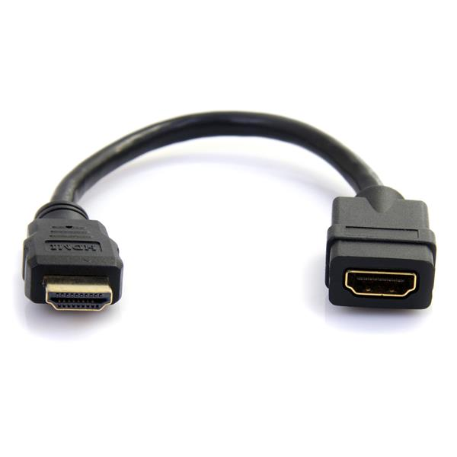
RJ-45 Ethernet Port | Connection to provide a wired connection to the PC. This would be located on the network interface card of the PC. | 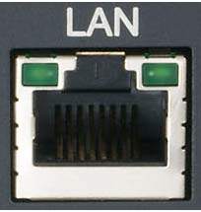
Disk Tray (CD/DVD) | A device that allows the user to insert a CD or DVD into a PC and read the files stored on the CD or DVD. Disk trays are slowly being fased out due to the widespread use of storage on the Internet. | 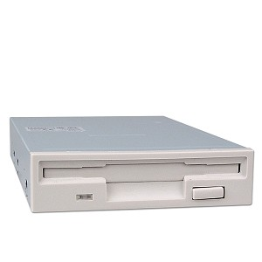
Display | The graphical hardware piece used to show an image from the PC to the user. An example would be a TV, monitor, cellphone screen, etc. | 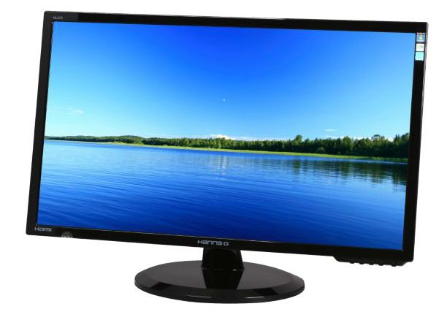
Mouse | An input device used to control a cursor on a screen to navigate the PC’s operating system. This can also be a touchpad on a laptop. | 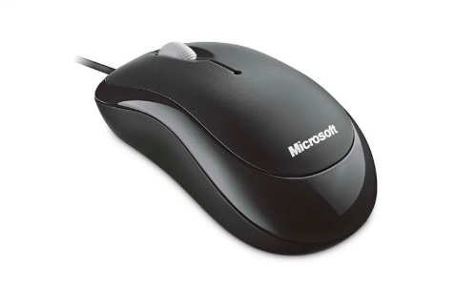
Keyboard | An imput device used to enter in text in a PC. | 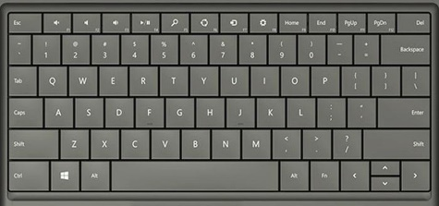

Now that we have covered the basic hardware components of a PC, let’s dive into the software that the hardware allows us to use!

Software
In terms of PC software, there are thousands upon thousands of different pieces of software that can be used. Whether someone is interested in cooking, digital media animation, programming, and beyond, there is software available to help in those interests. So we don’t get lost in the vast abundance of software, we will only focus on both common software packages (good and bad) as well as common software packages used here at Paul Smith’s College:

Software | Description | Icon
Microsoft Word | A graphical word processing program that a users can type with. It is used to create,edit, and save documents.
Microsoft Excel | A spreadsheet editing software that features calculations, graphing tools, and macro programming languages.
Microsoft Powerpoint | A presentation software that utilizes slides that can convey information with multimedia.
Microsoft Visio | A diagramming and vector graphics application to create a logical representation of an idea, environment, or work flow.
Java | A programming language utilizing an object oriented programming model. Most software packages utilize Java programming in order to run properly.
Adobe Reader | Application that is used to display and print Adobe Acrobat documents or PDF files.
Adobe Flash | A multimedia and software platform used to create graphics, animation, browser games, Internet/desktop/mobile applications. It is needed to run software utilizing Adobe Flash.
Command Prompt | A command line interface (CLI) that is all-text display used to run commands by a shell. You can use this to run programs by entering the correct commands. | 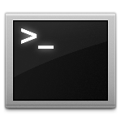
Notepad++ | An advanced version of Notepad, it is a graphical word processor with a focus on being a program writing platform. It allows for better syntax control and organization of code.
SysAid | A ticketing software which allows for submission, organization, and communication of IT related problems between end users and the IT department.
VLC | Open-sourced software that supports a wide variety of video formats.
Quicktime | A multimedia player created by Apple.
Realplayer | A multimedia player that plays RealAudio and ReadVideo file formats created by RealNetworks.
AVG | An anti-virus program used to detect, prevent, and scan for malicious content on a host computer.
Virus | Malware program that, when excecuted, replicates inside of a host and makes the device compromised to attacks such as key logging, editing user informaiton, and other malicous acts. | N/A
Adware | Malware program that presents unwanted advertisements on a computer. They are sometimes in the form of pop-ups, or windows you cannot close by normal means. | N/A
Trojan | A program with harmful code that is contained inside of an apparently harmless program until it is activated. | N/A
Spyware | Malicious software that aims to gather information about a person and/or organization without the user being aware. | N/A
QuickBooks | Set of software solutions designed to manage payroll, inventory, sales and other needs of a small business.
Minitab | A statistical analysis software to learn and perform statistical math.
ArcGIS | A geographic information system (GIS) for working with maps and geographic information.
MicroSurvey CAD | A Complete Desktop Survey and Design Program created for surveyors, contractors, and engineers.
NED3 | A forestry management and research gathering software.
SVS | Creates graphic images depicting stand conditions represented by components. | 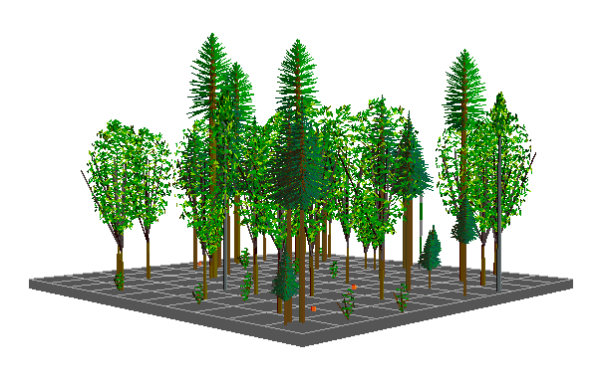
StewPlan | Helps resource professionals develop a Landowner Forest Stewardship Plan as part of the forest stewardship program sponsored by the US Forest Service and state forestry agencies.
NutritionCalcPlus | A suite utilizing dietary self-assessment tools. | N/A
FragStats | Compute a wide variety of landscape metrics for categorical map patterns. | N/A
Internet Explorer | A graphical web browser developed by Microsoft. It is installed on all Windows based PCs by default.
Google Chrome | A graphical web browser developed by Google. We recommend users use Google Chrome as much as possible.
Mozilla Firefox | An open-source, graphical web browser based on the Mozilla code.

Now that we’ve address all of these software packages, let’s talk about the bridge that allows us to utilize our hardware and software efficiently and effectively. I’m talking of course about the operating system!

Operating System
By definition, an operating system is a graphical user interface (GUI), that supports a computer’s basic functions such as excecuting applications, scheduling, and controlling peripherals. Before the operating system, users needed to enter in code through a command line interface (CLI), that only accepted and displayed text. Also, the user needed to create code to excecute programs or algorithms in order to get a specific task done. For the purpose of explaination, let’s navigate to a file in our “Downloads” folder in an operating system versus a command line interface. Let’s start with the CLI:

CLI:
- We need to navigate into the C: directory to see where we begin.

- Now that we’re in the C:\Users directory, we need to see the other directories within this directory. So let’s use the “dir” command and find out.
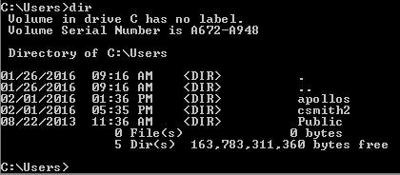
- Ok, so now, I want to go into the csmith2 directory, and see if my file is in there. Let’s go!
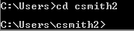

- Let’s check this directory for the Downloads directory.
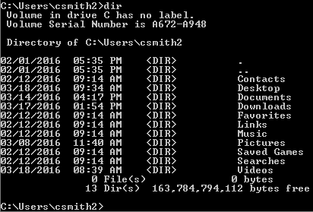

- There’s the Downloads directory, now let’s go inside of that directory, and look for our file!
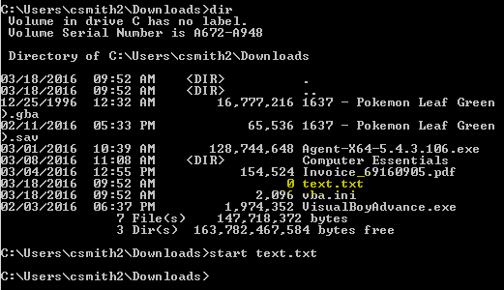
- In this example, we found our file called text.txt! That’s great and all, but how do we get into it? Well, we need to start the file by launching it in CLI.
- Congratulations! You have found your file, and opened up the file. Now let’s do the same thing in your Operating System
Operating System:
- Open up File Explorer
- Expand “This PC”, and click on Downloads and find the “text” file.
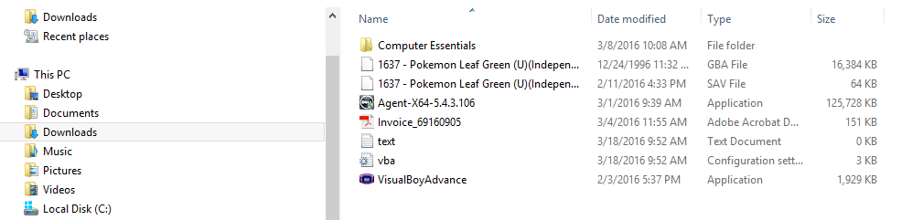
- Double-click the “text” file. Congratulations! You found your file, and opened up the file.

Now after doing the same action through both the CLI and the Operating System’s GUI, which process do you think is easier for normal users to understand? If you guessed the operating system, you’re right! This is how Bill Gates created the titan that is Microsoft; arguably one of the most successful technology companies of our time. Operating systems allow end users to easily excecute the same CLI commands but with buttons, graphics, and easy to remember paths. Other than the Windows operating system, here are a few other operating systems for both computers and mobile devices:

Operating System | Platform
OS X | Apple
Linux | Open-Source (almost all devices)
iOS | Apple iPhone
Android | Most non iPhone mobile devices

Congratulations! By finishing Part 2, you should have an understanding on the in’s and out’s of a PC as well as a few other end-user devices (which we will cover later in Part 5.) Just to reinforce these three pieces, let’s quickly review:
- Hardware are physical components used to create portions of a PC. Hardware pieces including RAM, Motherboard, Power Supply, and Hard Disk Drive are just a few hardware pieces that come together, to create the physical PC.
- Software are applications used to allow the end-user to complete desired tasks such as creating this document, crunching math problems, and even watching movies and TV shows on the PC.
- Operating systems allows the user to easily navigate through software on the PC efficiently and effectively without the hassle on doing the same processes through a command line interface.
Now that we have an understanding of a PC, let’s begin connecting it to a network so we can communicate and share information with other PCs both on campus and with the rest of the world!

Part 3: Basics of a Network

Overview
By definition, a network is a connection of multiple computers with the purpose of sharing resources. To give an example, let’s try sending a message to someone in another country without a computer network and with a computer network.

Without a network:
- If there was no computer network to send a message to someone in Italy for example, you would have to first obtain his or her home address. Next, you would have to physically write the message you want to be delivered. After that, you purchase an envelope, stamp, and deliver the letter to the post office where it is then delivered to the destination in a matter of weeks. Once a few weeks go by, the message is hopefully delivered to the other person. If it isn’t, then you would have to wait for the letter to hopefully return to you, or it’s simply lost forever.

With a network:
- If there was a computer network to send a message to someone in Italy for example, you would first have to know his or her e-mail address. Next, in your preferred e-mail account, you would type your message in an e-mail that you want delivered. After that, you enter the recipient’s e-mail address, and click “Send”. In seconds, the message is delivered, and confirmed as delivered so you know that the person received the entire message.

Based on the differences between not having a computer network and having a computer network, which one do you think is the fastest and most reliable method of sharing resources? Unless you like the feeling of physical paper, pens, and the rush of snail mail, the choice should be obvious. This obvious choice (a computer network just to make sure we are on the same page), is the same choice billions of people around the world decide to use every single day to share resources. However, as an up and coming jack of all trades in the IT field, you may be asking yourself, “How does it all work?” To begin, let’s start with the foundation of computer networking and work our way to sending e-mail messages to that special someone in Italy.

Network (Device Checklist)
Before we think about the giant that is a network, let’s break it down even further to its individual pieces. First, let’s look at what is required for an end-user device to connect to a network. For the hardware pieces that allows for network connectivity, please refer back to a network interface card (NIC) back in the “Hardware” section, under Part 2, on page 8. For the configuration pieces, let’s look at the following example:
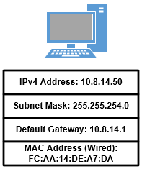
Figure 2 - Basic Network Information
When talking about an end-user device connecting to the network, it must have the following:
- Network Interface Card (NIC)
- IP Address
- Subnet Mask
- Default Gateway
- MAC Address

In Figure 2, this device meets the basic requirements required to start a network connection. Let’s dive deeper, and focus on each piece, as well as its purpose:
- IP Address: An Internet Protocol (IP) address is a unique string of numbers that identifies each computer in order to communicate over a network. In today’s networking standards, there is both Internet Protocol version 4 and version 6 (IPv4 and IPv6). In our network at Paul Smith’s College, we utilize IPv4. To provide an example, please refer to Figure 3. In a campus environment, an IP address is like having a student ID in Campus #1. If the ID number that Person A is assigned is #0001, then that person will be identified with that number across campus. If another person was added to campus, Person B would then be assigned #0002, because each person is assigned a unique ID number. The same principle applies for end-user devices on a network.
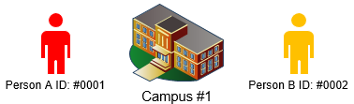
Figure 3 - IP Address Example

- Subnet Mask: A subnet mask is a binary pattern stored on the end-user device that matches with the IP address to determine which network segment information is destined for. Let’s branch off of Figure 3, and refer to Figure 4. In Campus #1, there are halls where students can live on campus for the entirety of their education. For organization, anyone with the student ID number between #0001 through #0010, stay in Town House #1. That way, if Person A receives a care package from mom or dad, we know that Person A lives in Town House #1 based off of his or her ID number being between #0001 and #0010.

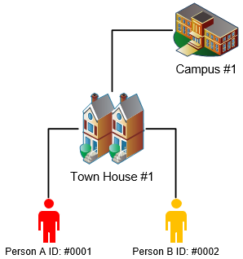
Figure 4 - Subnet Mask Example

- Default Gateway: A default gateway is an access point or IP router that a networked computer can send information to another computer on another network or the Internet. Expanding off of Figure 4, let’s refer to Figure 5. In Person A’s care package, Person A realizes that mom send her the wrong pair of running shoes and needs to send them back. Since Person A’s mom doesn’t live on Campus #1, she needs to go to the post office on Campus #1 and mail the package back to her house. This is the same process an end-user device uses to access the Internet. If an end-user wants to go to www.google.com, that device needs to send the request to its default gateway where the user assumes that router will know where to send the request. The same principle applies back to the post office. Person A gives the package to the post office assuming that post office will know where to send the package.

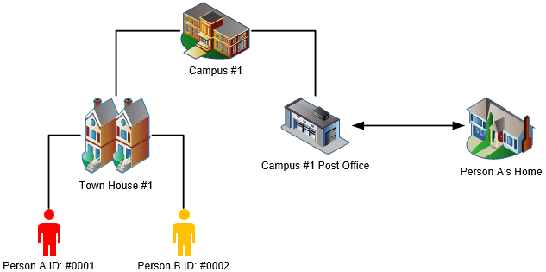
Figure 5 - Default Gateway Example
- MAC Address: A MAC address is the physical address attached to a network interface card that provides the end-user device network connectivity. It’s separated in six groups of two hexadecimal digits, separated by hyphens (-) or colons (:). Also, they range from 0-9 and A-F for example (01-23-45-67-89-AB). Continuing off of our campus figures, a MAC address goes deeper than the school. In fact, it would have started right at birth of either one of these two students. When Person A was born, she was assigned a Social Security Number. This number is assigned to her and no one else on planet Earth. This number will never change, and this number cannot be taken away from her. This is how a MAC address works. When a NIC is created, it is burned into its circuitry its MAC address which is unique to that device. That MAC address was assigned to that NIC and no other NIC on planet Earth.

Network (Segments)
- Local Area Network (LAN) - A network that connects computers and other devices in a relatively small area such as a building and/or a group of buildings. In our previous examples, the entirety of Campus #1 would be considered a LAN because it is all in the same relatively close area much like Paul Smith’s College.
- Wide Area Network (WAN) – A network that expands over a large-scale geographical area. A WAN connects different LANs together. In Figure 6, Campus # 1 and Campus #2 are connected to the same Internet Service Provider (ISP). As a result, the ISP is creating a WAN because two different LANs are connected to it. This allows Person A from Campus #1 to communicate with Person A from Campus #2 and vice versa.

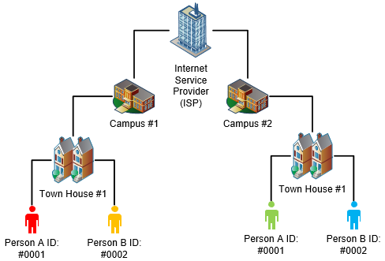
Figure 6 - WAN Example
- Wireless Local Area Network (WLAN) – Similar to a LAN, a WLAN is a connection of computers over wireless in a relatively small area. In short, you can either be in a LAN (wired) or in a WLAN (wireless). Within a wireless network, there is also a service that broadcasts the WLAN known as a Service Set Identifiers.
  - Service Set Identifiers (SSID) – A SSID is a name assigned to a WLAN when being broadcasted. Since wireless doesn’t require a physical connection, there can be multiple wireless networks that can be advertised to users. At Paul Smith’s College, our SSIDs are the following:
    - PSC Student
    - PSC FacStaff
    - PSC Open

- Virtual Local Area Network (VLAN) – Similar to a LAN, a VLAN is a partitioned and isolated domain in a computer network at the data link layer. Essentially, a LAN can be separated into even further virtual LANs for ease of management. In Figure 6, let’s add two academic buildings onto Campus #1. Before VLANs, there are no labels on any of these buildings. If we want to assign a purpose to these buildings, we need to give them a name. For this example, let’s assign Building #1 as the Financial Aid department and Building #2 as the Admissions department. These new names now logically separate the buildings on Campus #1. This is the core purpose of a VLAN. It allows management to have a better understanding on how their network is separated and assigned. Without VLANs, it would all be one, flat LAN without any information about the other portions of the network you would like to label.

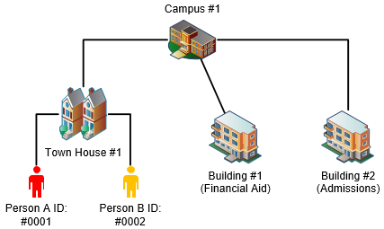
Figure 7 - VLAN Example

Network (Equipment)
Hardware | Description | Example
Switch | A device that connects other devices together on a network by using packet switching to receive, process, and forward data to its destination. | 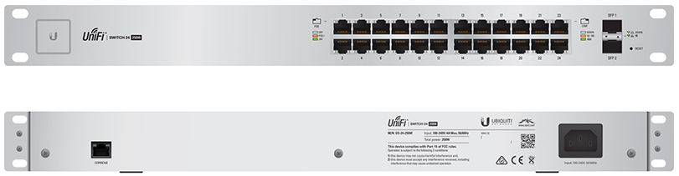
Firewall | A system designed to permit or deny access to or from a private network. This can be in the form of hardware, software, or both. | 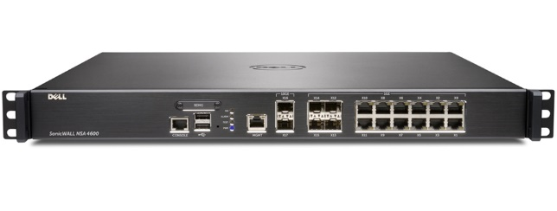
Modem | A device for modulation and demodulation between digital data of a computer to an analog signal for a coaxial line. | 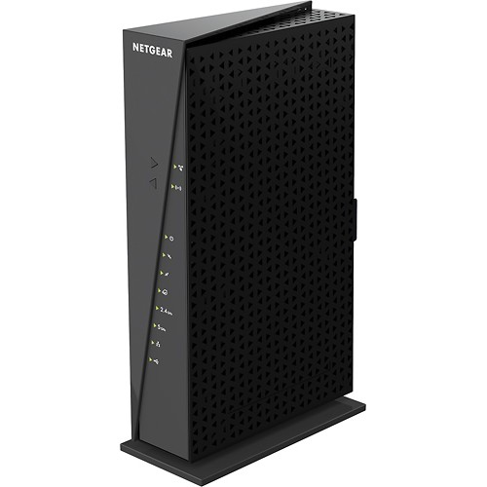
Wireless Access Point (WAP) | A hardware device on a LAN that allows wireless devices and wired network to connect through a wireless standard most commonly, Wi-Fi or Bluetooth. | 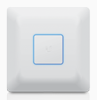
Cat5e Cable | A type of cable used in structured cabling in networks such as Ethernet. It can support:  - 10Base-T  - 100Base-TX  - 1000Base-T | 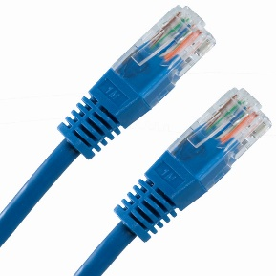
Cat6 Cable | A type of cable used in structured cabling in networks such as Ethernet. The difference between Cat5e and Cat6 is Cat6 has a plastic piece within the cable to further reduce interference. Also, it is certified for Gigabit networking and performs better over longer distances. It can support:  - 10Base-T  - 100Base-TX  - 1000Base-TX | 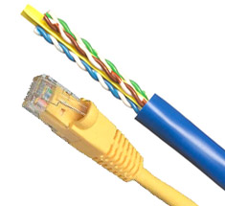
Console Cable | A cable to physically connect to a network device when performing maintenance when other connection types are not an option. | 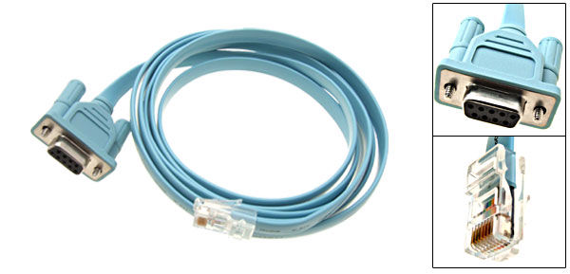
Fiber Optic Cable | A cable type that transmits information as light pulses along a glass or plastic wire or fiber. Fiber optic wire carries much more information than Cat5e/6 and is far less susceptible to electromagnetic interference. | 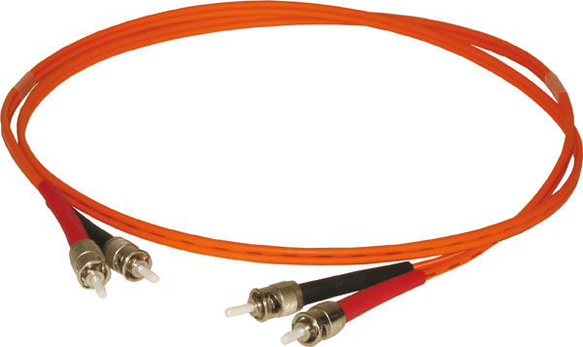
Small Form-Factor Pluggable (SFP) | A module transceiver, it allows network equipment to convert fiber optic light into digital data. | 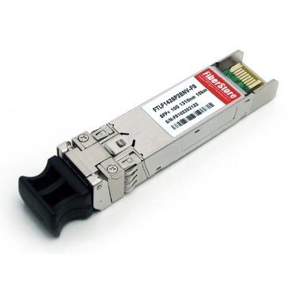
Console Port | A port to accept a console cable connection. | 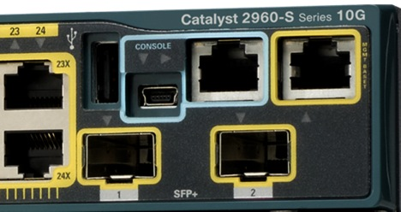
SFP Port | A port to accept a SFP module connection. | 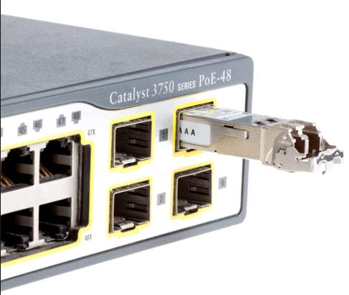

Congratulations! By finishing Part 3, you should have an understanding on the in’s and out’s of a network, and how one is used to communicate information from one end-user device to another. Before moving on, let’s recap:
- A network is a set of computers connected together with the purpose of sharing resources.
- A network can be local (LAN), or wide (WAN), which allows us to connect to other users across the world!
- In order to do this, networking equipment is required over different mediums to properly transmit and receive information.
Now that we are able to communicate information across the network, it is time to begin adding features that allows us to have better control over users within our LAN, provide resources for those users, and keep our user’s information as safe as possible.

Part 4: Basics of a System

Overview
By definition, a system contains the following:
- Multi-user computing environments consisting of hardware and software configurations
- Establishment and creation of user accounts
- Upgrading software
- Maintaining backups and recovery tasks
- Creation, maintenance, and distribution of servers
With these different types of systems in place, it allows a user to properly navigate across the LAN to access the resources he or she needs. For example, in our LAN environment, we have a system in place where you are assigned a username and password. That username and password allows you to log into any campus owned computer on campus, which will then carry over any permissions you have at that computer. You can also use the same username and password to log into your e-mail at any computer. This is just one of many options that systems like these provide us. In the IT body, it is essential that we look at all of the details of user accounts and their integration with other systems to ensure that the two come together as one; to provide a positive user experience. To begin, let’s talk about the fundamental pieces that allows for these integrations to occur.

System (Servers)
In order to provide an area to host our systems, we first need to create servers which, will serve users the tools that they request. Without servers, certain pieces of information would have to be entered in by either the IT department and/or the user every time they log into a computer. For example, without a DHCP server, the IT department would have to have a physical document which contains all of our available IP addresses on campus. If someone wanted to connect to the LAN and/or WLAN, they must first come to the IT department, ask for an IP address, and manually configure that address onto their machine. Obviously this doesn’t provide a positive user experience like we mentioned prior. This would be very time consuming for both the IT department as well as the user. In order to drastically reduce this time, we have a DHCP server which will automatically hand out IP address for those users who connect to the LAN and/or WLAN. The following are the most common and most critical servers that most LANs will have:
- DHCP
- FTP
- DNS
- Print
- Active Directory

- Dynamic Host Configuration Protocol (DHCP) – A DHCP server is a network protocol that enables the server to automatically assign IP address to a computer from a defined range of addresses. Let’s go back to our campus example by referring to Figure 8. In Figure 8, Campus #1 has now given the Admissions department located in Building #2 a new task. It is now Admissions job to assign new users an unused ID out of the Person ID Pool. This allows for new students being enrolled to automatically have a Person ID without them having to manually create one on their own which may not be correct or may already be in use. This is the same task that a DHCP server has. It’s the DHCP server’s job to hand out unused IP addresses out of the IP pool to new users. Although this system makes distribution easy, time will ultimately ruin this system. With the current system in place, what happens when there are more than 1,000 students on Campus #1? How will they get an ID? What happens when Person A graduates? In order to address time, we implement DHCP lease times.
  - DHCP Lease Time – A DHCP lease time is a period of time assigned to each IP address assignment to determine how long the user will have the IP address for. To continue off of our example, let’s add some lease time rules. On Campus #1, only enrolled students are allowed to have a Person ID. Once Person A graduates, the lease time is up and ID #0001 is placed back into the Person ID Pool ready to get redistributed. This is how DHCP lease times work with an IP address. In our LAN, our DHCP lease times are set for a week. After a week has passed, the end-user device will lose its IP address and will only obtain a new one if it is connected to the network, or request a new address. Lease times are incredibly useful especially in a WLAN due to the large volume of new wireless device entering and leaving campus.
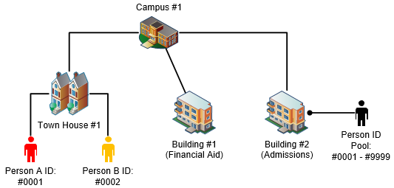
Figure 8 - DHCP Example

- File Transfer Protocol (FTP) – A FTP server is a network protocol used to transfer computer files between a client and a server on a LAN. In Figure 9, Admissions now has the responsibility to automatically create schedules for every student on Campus #1. In this environment, the students have no say in what classes they can or cannot take. In order for students to know what their schedules are, they need to send a request to Admissions to receive their schedule. Once the request is received by Admissions, they reply back with the student’s schedule. This is the same principle when using an FTP server. Shared drives are a perfect example of the use of an FTP server. If you save your files on a server on our LAN, that server is utilizing FTP which allows you to do so.
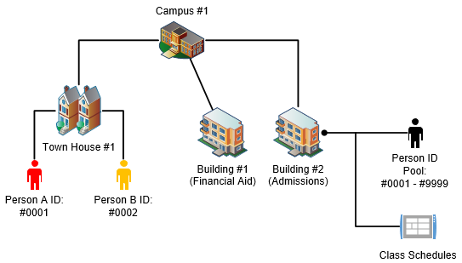
Figure 9 - FTP Example

- Domain Name System (DNS) – A DNS server is a system for naming computers and network services within a domain. It is used to assign user friendly names to numerical addresses. Going back to our example, let’s dive deeper into the student’s schedules. The table below shows the class schedule that every student will receive:
Course ID | Year | Course Name
0001-0101 | Spring 2016 | Algebra
0001-0202 | Spring 2016 | Technical Writing
0001-0303 | Spring 2016 | Public Speaking
From a student’s perspective, what do you think would be an easier name to remember when your parents ask you what classes you are going to take this semester? If you said Course ID, you’re a computer and this makes sense. If you are human, you hopefully said Course Name! In this schedule, the Course ID and the Course Name are one in the same. The Course ID is used for better backend management of courses while the Course Name is used for defining the course for students and faculty. This is the same principle used with DNS. For example, when you go to the website, www.google.com, you are actually connecting to the IP address of, 206.111.13.21. In fact, if you type in that IP address in your Internet browser, you will be going to www.google.com. Cool right? Now with this in mind, what is easier for an end user to remember? Google, or 206.111.13.21? Both lead to the same page for Google, but simply remembering www.google.com is much easier than remembering 206.111.13.21.

- Print – A print server is a server that connects printers to client computers over a network. It accepts print jobs from clients, and sends those jobs to appropriate printers, queuing jobs locally, and providing the necessary drivers for the client to properly print to the desired printer.

- Active Directory – An Active Directory is a Windows OS directory service that manages interconnected, complex, and different network resources in a unified manner. Figure 10 now shows that the Admissions department now controls the ID numbers for both Students and Faculty. Admissions is now becoming the point of contact when someone joins Campus #1, needs their ID changed, or needs schedule information. For example, if a Faculty member wants to know the schedule for Person A, then they would find this information at the Admissions department. Active Directory works in a similar fashion. Active Directory holds the users and computers that are on the LAN. If a user is being added to the network, you add that user to Active Directory. If a user is being moved into another group (moved from a Student to a new Faculty member), you change that person’s group assignment in Active Directory. If a user no longer is active on the LAN, you can delete that user in Active Directory. All in all, it is the central hub for all things users and computers in terms of organization, and their abilities to navigate across the network.
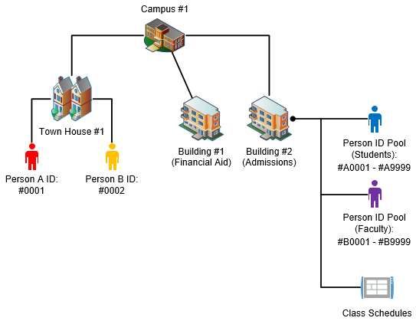
Figure 10 - Active Directory Example

- Voice over IP (VoIP) – A VoIP server controls VoIP phones like numbers, configurations, and network information on a LAN. This is very similar to the same controls over computers on a LAN, but this simply separates the two roles for easier management.
- Ports (Non-Physical) – Non-physical ports are ports that are used for session protocols. For example, Figure 11 shows one cell phone with the option to utilize three services:
  - Emergency
    - Dial: 911
  - Before you Dig
    - Dial: 811
  - Paul Smith’s College Helpdesk
    - Dial: x6465
By default, you making a call to either three of these numbers is still utilizing the same standard to transport your call from you to the receiver. The difference is, that you are utilizing a different service for all three calls. If you want to call the Helpdesk, you are requesting computer help not Emergency help. To separate these services over the same channel, you utilize a number associated to the service. If you want the services of the Helpdesk, you call over the number x6465. If you want Emergency services, you call over the number 911. The same applies for non-physical port numbers.
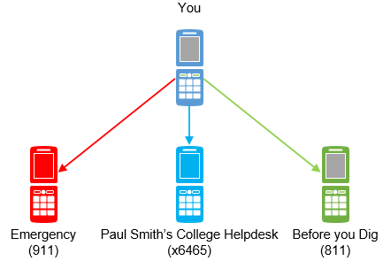
Figure 11 - Non-physical Ports Example

When you launch a web browser, you could either be accessing a web page over Hypertext Transfer Protocol (HTTP) or Hypertext Transfer Protocol Secure (HTTPS). When you go to a web page utilizing HTTPS, it automatically uses a port number associated with HTTPS. By default, this port number is 443. When you go to a web page utilizing HTTP, it automatically uses a port number associated with HTTP. By default, this port number is 80. These are just a few non-physical port numbers used in IT, but this provides a good idea on what they are and their purpose.
- Network Controller – In our environment, a network controller is a central graphical user interface which allows us to monitor, configure, and troubleshoot the entire LAN. Before a network controller, the network administrator would have to either remote into each individual switch or physically connect to perform a task or troubleshoot an issue. A network controller allows us to configure a switch and/or access point from the same management console. As a result, this saves in both troubleshooting time as well as administration time.

Congratulations! By finishing Part 4, you should have an understanding on the in’s and out’s of a system, and how its used to provide control and functionality to all users on the network. Before moving on, let’s recap:
- Servers are used to host all the resources that users interact with on a daily basis. Wether it’s a user account, accessing a printer, accessing a file on the network, or managing networking equipment, they are all hosted on servers.
Now that our IT body has the majority of its system covered, let’s talk about the devices that navigate across the IT body. These are known as end-user devices.

Part 5: Basics of End-User Devices

Overview
In any organization with an IT body, desktop computers are no longer the only device that end-users have access to. If for example someone wants to print out a document that they typed in Microsoft Word to give to another person, they need a device that can print it. The device that would be used would be a printer. Let’s take it a step further and say that while the person was walking from one part of campus to another, they forgot to let the other person know what time they would be meeting them to deliver the paper. For convenience, the user uses his or her mobile device, which is connected to the WLAN, to send an e-mail to the recipient of the document about the meeting time. These are just a few examples of other end-user devices outside a desktop. The following are common end-user devices that navigate across the IT body:
- Desktop
- Laptop
- Mobile Devices
- Tablets
- VoIP Phones
- Projectors
- Printers
In essence, all of these devices carry similar traits in order to properly navigate the IT body. It’s these traits that one must understand and when one does, each unique end-user device can be approach in the same way!

End-User Devices (Examples)
Device | Definition | Example
Desktop | A personal computer that is stationed normally at a desk with a vertical or horizontal tower. Moving forward, desktop computers are becoming so small, that they are either being merged with the monitor or installed on the back of a monitor. | 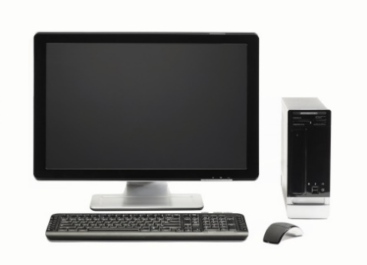
Laptop | A personal computer that is portable and suitable for travelers. Normally, a laptop’s monitor doubles as a lid which, when closed, allowed for easier transportation and light protection to the screen and keyboard surface. | 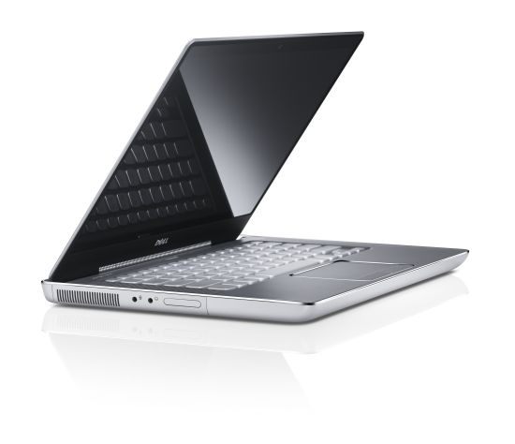
Tablet | Similar to a laptop, a tablet is also portable but provides a touchscreen functionality which eliminates the need for a physical mouse/keyboard. | 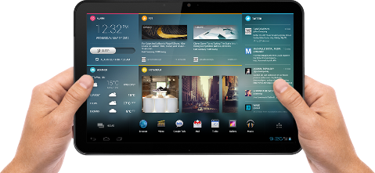
Mobile Device | A device normally referred to as cell phone, it provides voice communications, messaging, Internet services, and can run thousands of applications (Apps) created for the specific mobile device. A mobile device can either connect to the carrier’s cellular network, or connect to a wireless network to provide network connectivity to the WLAN or Internet. | 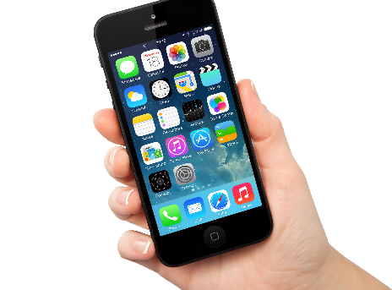
VoIP Phones | A phone that can make phone calls over a digital signal. Normally, this is done over the Internet Protocol (IP) or the voice is over IP or VoIP. VoIP phones can provide additional functions such as voicemail configuration, button mapping, access to a dynamic phone directory, and other features. | 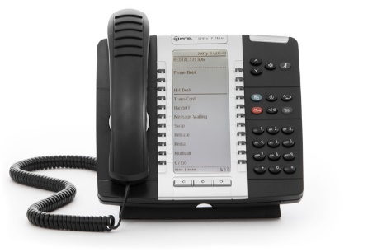
Projector | A device that projects light through lenses for projecting an image or a video onto a screen. Projectors are normally connected to desktops and/or laptops when presenting information to multiple users at the same time in the same room. | 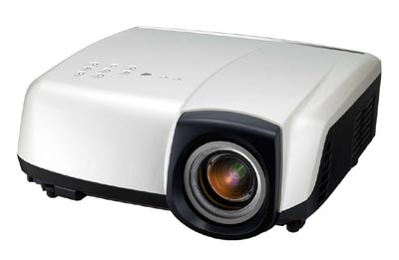
Printer | A device that receives text and graphic output from a computer and transfers the information onto paper to produce a physical version. Printers can either connect to a computer either locally through a USB connection or through the network. Furthermore, printers can either be for a single person or shared for any user to print to. | 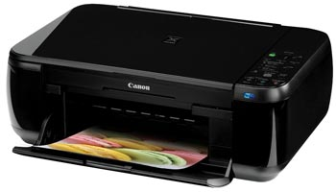

Congratulations! By finishing Part 5, you should have a foundational understanding on other end-user devices outside of a desktop and a laptop. These devices just continue to provide accessibility to tools and resources to transfer information either physically or electronically.
Now that we have finished discussing end-user devices, that means that all of the major pieces of the overall IT body have been covered. Before we move on, let’s tie everything together so we can see how all of these different pieces tie in with each other. Remember back at Figure 1 when we looked at a small snapshot of Paul Smith’s College’s IT body? That IT body contained all of the pieces that we mentioned throughout this guide. Let’s start from the beginning, and, like a human body, add all of the fundamental pieces one by one:
- A network is created to lay down the foundation on which the IT body can expand on. Think of a network as the IT body’s skeleton.
- A system is then added onto the existing network providing crucial services hosted on servers. Think of a system as the vital organs of the IT body.
- End-users are then allowed access to the network and systems bringing with them multiple devices such as desktops, laptops, tablets, and so on. Think of these devices as cells, oxygen, and nutrients to the IT body. Without them, there is no need for the IT body to exist.
- To allow the IT body to accept the benefits of end-user devices, the end-user devices must agree to a set of protocols in order to function properly. Think of these standards and protocols as good organisms marked by the IT body. Anything that isn’t following these standards and protocols may be marked as malicous or be seen as a virus to the IT body.
Like a human body, diseases occur within us daily. Fortunately, our bodies have created antibodies and immunities to these diseases which allows us to naturally fight them off to continue living as healthy as possible. When our bodies cannot fight these diseases alone, we go to a doctor to ask for further assistance to return to feeling better. There is no difference between seeking help from a doctor or seeking help from an IT technician when the human body or the IT body needs further help. For the IT body, we are considered the doctors and it is our job to collect as much information as possible about the problem, analyze the symptoms, create a diagnosis, and implement a plan of attack to correct the issue. Like a doctor, an IT technician needs to have a very clear understanding on the in’s and out’s of the IT body, in order to gather as much information as possible to perform the right call to action. If this isn’t done, then the problem may not be fully solved, and the problem may either resurface at another time, or cause part of the IT body to be operated on which costs time and money for everyone involved.

Part 6: Basics of Troubleshooting

Overview
Like mentioned previously, we are considered the doctors of the IT body. It is our job to analyze a problem, gather information, create a diagnosis, and implement a solution in order to correct the problem. Once this flow of troubleshooting is mastered, you will have a great tool at your disposal to provide a solution both efficiently and effectively. First, like a doctor has medical guides and journals at his or her fingertips to point them in the right direction, we also have something similar. Our master guide is what’s known as the OSI Layer, and it is the foundation for all things related to IT troubleshooting.

Troubleshooting (OSI Layer)
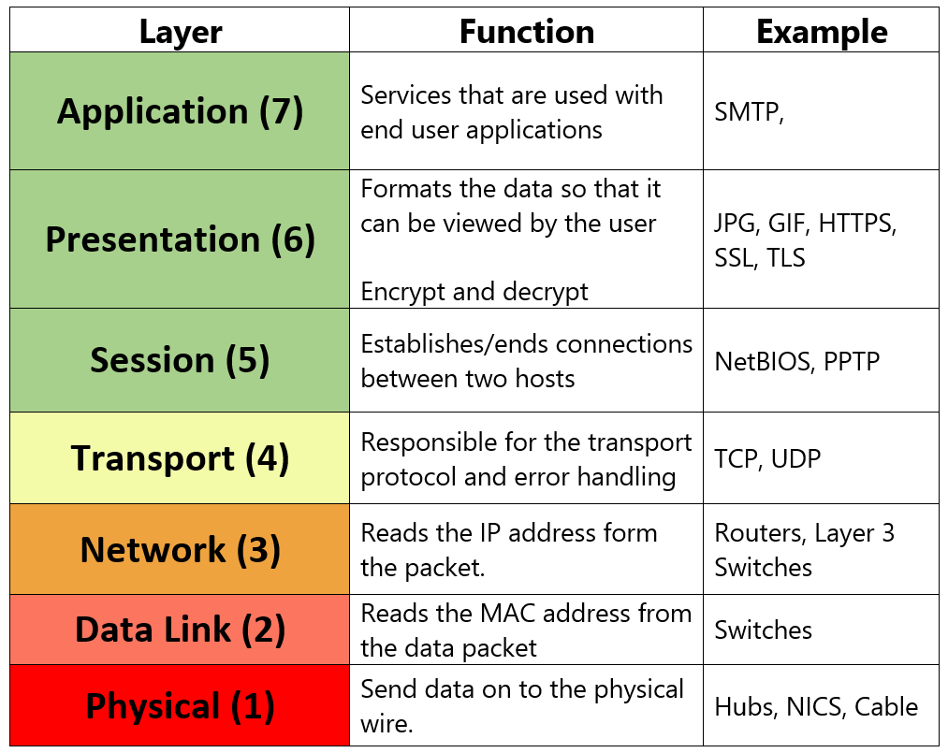
By definition, the Open System Interconnection (OSI) model is a logical model that characterizes and standardizes the communication function/path of a telecommunication or computing system. In short, it is a guide that can be applied to all things related to telecommunications when attempting to solve a problem. Figure 12 shows the entirety of the OSI Layer which starts at the Physical Layer and works up all the way to the Application Layer. It also provides a brief overview on its functions and examples. Before going deeper into each layer, try to remember the following:
Figure 12 - OSI Layer Example
- Please
- Do
- Not
- Throw
- Sausage
- Pizza
- Away
See a pattern here? The “P” in “please” represents the Physical Layer, the “D” in “do” represents the Data Link Layer and so on. This is just a friendly aid to help you understand the different layers and the direction that it should be navigated (bottom-up approach). Now let’s get deeper into each layer by referring to the “OSI Layer” PowerPoint located in our IT Department shared folder! Now that we’ve discussed some sample questions within each layer, let’s dive into scenarios, and see what information we need in order to correct the problem!

Troubleshooting (Proper Information Gathering)
In order to strengthen our understanding on the OSI Layer let’s run through a few examples, and see what information we can gather.

Issue #1: A staff member calls on their office phone saying that the network is down.

Before we continue, try thinking or writing down questions below in the space provided that you would ask the user and see if they match or are close to the ones listed in Issue #1.

Your Questions:

- ________________________________________________________________________________________________________________________________

- ________________________________________________________________________________________________________________________________

- ________________________________________________________________________________________________________________________________

- ________________________________________________________________________________________________________________________________

- ________________________________________________________________________________________________________________________________

- ________________________________________________________________________________________________________________________________

Now let’s begin gathering information on the reported problem. First, let’s assume that the user is still on the phone to report the issue:

Person A: “My network is down on my desktop.”

IT Technician: “Is your desktop connected through your office phone?”
- This question would be starting at the Physical Layer. The reason being is that within our infrastructure, office computers are commonly connected through a second Ethernet port on the back of the VoIP phone. That way, it eliminates the need to have dedicated ports for the phone and the desktop.
  - Tip: In most cases, you will have a caller ID function on your VoIP phone which can give you a great deal of information. For example, if Person A is calling on their office phone and the caller ID says, “Person A”, then that means that they are able to successfully call you over the network. That means that the phone has network connectivity which can eliminate the possibility of the entire building not having network connectivity. If the caller ID says, “Cell Phone”, then that may mean that their office phone may be not functioning as well or they simply thought it was more convenient to use their cell phone at the time rather than their VoIP phone.
Person A: “Yes it is.”

IT Technician: “Are you using that same phone to make this call?”

Person A: “Yes I am.”

IT Technician: “How do you normally connect to the network?”
- Although the user says that they are using a desktop, you should always rule out any other possibility before continuing. For example, Person A may tell you that they are using a desktop, but they may be talking about their docking station connected to a laptop. You wouldn’t know if they were confusing the two without either asking questions to rule out that possibility or physically seeing the setup. Now this question is investigating the Data Link Layer to determine what connection type the user is actually using. They could either be using wired or wireless.
  - Tip: A great way to quickly determine what connection type they are using is to describe to the user what network symbols mean what. For example, if you say, “Do you see ascending bars or a computer monitor with a little cable on the left-hand side of it?”, you are actually asking them if they are currently connected to wireless or wired without using IT jargon. That way, the end user can provide you better information without even knowing it!

Person A: “I think I’m normally hardwired, but I’m not too sure.”

IT Technician: “In the bottom right-hand corner of your screen, do you see ascending bars or a computer monitor with a little cable on the left-hand side of it?”

Person A: “I see the monitor with the cable.”

IT Technician: “Ok. On that same icon, are there any symbols over it like a red circle with an ‘X’ through it or a yellow triangle with an “!” through it?”
- This next question is utilizing the error messages that the Windows operating system gives us. In short, these error messages gives us a better focus on where the problem lies.
  - Tip: If the error symbol is , then that normally means that the either the physical cable is at fault, the NIC may be damaged, disconnected, disabled, or the switch port may be damaged, disconnected, or disabled. This can put the focus on the Physical Layer.
  - Tip: If the error symbol is , then that normally means that the network configuration may be wrong, or that the computer isn’t getting the proper network information to navigate the network. This can put the focus between the Data Link and the Network Layer.

Person A: “I see the red circle that you mentioned.”

IT Technician: “Would you kindly double-check your cables connection from the back of the phone to your desktop computer?”

Person A: “Sure one second…OK I checked, and everything seems to be connected fine.”

IT Technician: “I appreciate all of the information. It sounds like your cable may have went bad. I will be down as soon as I can with a working cable.”
- If the user reports that the cable was connected properly, it could mean that the cable was damaged. This is common for those who have cords in very tight spaces or if Ethernet cables are across the floor and may be run over by their office chair on a regular basis. At this point, you should have a strong plan of attack to determine that replacing the cable with a known good one will alleviate the issue. If it doesn’t, simply gather more information on-site, and plan your next plan of attack.

Issue #2: A student comes in saying that they can’t open a PDF document.

Before we continue, try thinking or writing down questions below in the space provided that you would ask the user and see if they match or are close to the ones listed in Issue #2.

Your Questions:

- ________________________________________________________________________________________________________________________________

- ________________________________________________________________________________________________________________________________

- ________________________________________________________________________________________________________________________________

- ________________________________________________________________________________________________________________________________

- ________________________________________________________________________________________________________________________________

- ________________________________________________________________________________________________________________________________
Now let’s begin gathering information on the reported problem.

Person B: “I can’t open up my PDF”

IT Technician: “How are you trying to open the PDF?”
- This question may need to be expanded upon, but this will allow you to determine if Person B is opening a “.pdf” file in an application that can open a “.pdf” file like Adobe Reader.

Person B: “In Microsoft Word because our professor will only accept Microsoft Word documents.”

IT Technician: “Unfortunately, you cannot open a PDF in Microsoft Word. You would need to open up the PDF in Adobe Reader. Also, if you are trying to convert the PDF information into Microsoft Word, you need a program that converts PDF files to Word files.”
- By asking the previous question, you determine that the user was trying to open a “.pdf” file in Microsoft Word. This is now focusing on the Presentation and Application Layers of the OSI Layer. The cause of the initial problem was that the “.pdf” file (Presentation Layer) cannot be opened in Microsoft Word (Application Layer). Secondly, the user would need to utilize special software that would covert the “.pdf” into the correct Presentation Layer format to be read by Microsoft Word. That would be converting the “.pdf” into a “.docx”.
  - Tip: A suggestion would be to always recommend free, reputable software first before recommending paid software. In this example, there are dozens of online conversion tools that can easily convert a “.pdf” into a “.docx”. If this works, then Person B’s problem is not only resolved, but they didn’t have to pay a cent to fix it.

These are just a few of hundreds upon hundreds of questions that you will be asked throughout your IT career. However, information gathering can only go as far as your attitude will take you. In the end of it all, these are people who want their needs met before anything else. Even if an entire classroom is down, they will still believe that their needs are more important. As opposed to resisting this fact, let’s embrace it, and use it to our advantage. Let’s discuss customer service skills in IT.

Troubleshooting (Customer Service)
In any customer service field, including IT, the customer is only concerned about one thing; their needs being met. Whether it’s a problem, concern, or an idea, it all stems from an idea that they own and possess, which emotionally invests themselves with that idea. That is why customer service is such an easy concept, but hard to truly master. To put it in perspective, most people will be more concerned with the pain in their toe than the thousands of people dying by genocide in Africa per month. Let that sink in for a brief moment. This realization shows that a person’s problems, ideas, or concerns are the most important thing in that person’s life at this moment. Luckily with great customer service skills, we can use this to our advantage. According to Dale Carnegie, author of How to Win Friends & Influence People, the best way to approach one’s personal needs and feelings is to make the person like you to the best of your ability. He further breaks this process down into six pieces:
- Become interested in other people.
  - Becoming interested in other people doesn’t mean that you need to like the person in order to be interested. Instead, look at it by being interested in the problem that they are experiencing, or the technology that they are using. For example, if a user had a problem with their iPad, you could be interested in their iPad asking them how they like it, what version it is, etc. This will show that you are interested in their device, and that you give them an opportunity to brag about it a little.
- Smile!
  - Smiling is one of the easiest/hardest traits to master. Naturally, it’s easier to smile on good days, but harder to do so on bad days. Rather than being hung up on the situation, simply smiling can turn a bad call or an angry patron into one that is cooperative. For example, many teleworkers are encourage to physically smile before they answer the phone because it will show through their voice. Try it out the next time you answer the phone and see how this works for you.
- A person loves the sound of their own name.
  - Ask yourself this one question. What would you rather have people say when they acknowledge you?
    - Hey! How are you?
    - Hey “Insert your name here”! How are you?
It may not seem like much reading it on paper, but people love the sound of their own name even if they aren’t aware of it. Keep aware of his or her name, and use it to show that you are being more personal with the individual.
- Be a good listener and encourage them to talk about themselves.
  - Being a good listener is an amazing tool for anyone to learn both inside and outside of IT. Sometimes, if you let someone vent without saying a word yourself, they may feel much better simply talking to a good listener rather than looking for advice or someone to fix their problem right away. When someone discusses their problem, they simply want to tell someone that their needs aren’t being met, and if you allow him or her to do that fully, true communication can occur.
- Talk in terms of the other person’s interests.
  - This expands on what you listen to. Normally, their current interest is to have access to a certain resource. However, with good listening skills, you can further defuse the situation by commenting on their interest related to his or her problem. Let me explain. If someone is having a hard time connecting their device to the wireless and through troubleshooting you determine that it’s an Xbox, you can comment on a new game that came out, or how you envy those who have an Xbox because of all of its cool features. Be careful when doing this because if you do not do so sincerely, then it will be more of a hindrance towards your customer service as opposed to providing value towards it.
- Make the other person feel important and do it sincerely.
  - Above all, make sure that the person’s issues are addressed, and make them feel as important as possible. For example, if a student reports that after coming back from Spring Break that their laptop no longer connects to the wireless, make them feel that the problem is important to solve. See the issue from their perspective as well as your own. See that after coming back from a break and then running into problems day 1, they now can’t go online to get back to school work. An IT technician could see how frustrating this could be, thus showing more interest in his or her problem which, in turn, makes the user feel important.

Part 7: Review Questions

- True or False: This is a correct MAC address – 45:00:34:AB:D3

- True or False: A NIC is only for a wired connection.

- True or False: A DHCP server assigns IP address.

- True or False: A default gateway is a binary pattern stored on the end-user device that matches with the IP address to determine which network segment information is destined for.

- True or False: A VoIP phone makes calls over Internet.

- What is a LAN?

- What is an operating system, and what is it primarily used for?

- What is a non-physical port and give me an example of one along with its common port number?

- List the 7 layers of the OSI model in order from bottom-up.

- What is the difference between a Cat5e and a Cat6 cable?

- What allows me to go to Google by typing in www.google.com as opposed to me typing in 206.111.13.21?

- What is a DHCP lease time, and what is it used for?

- What software is associated with the following icons:

Icon | Software

Word Bank:

Microsoft Office | Adobe Reader | AVG
Adobe Flash | Internet Explorer | VLC
Google Chrome | Microsoft Word | Microsurvey CAD

- What does a wireless access point do?

- What part of the OSI Layer deals with file extensions such as .pdf or .docx?

- What system allows an IT professional to add, edit, or delete user accounts?

- What is RAM and why is it important?

- Before operating systems, what text interface was used run programs and/or applications?

- What port allows a Cat5e or Cat6 to connect to it?

- What hardware piece is considered the brain of the computer?

- According to Dale Carnegie author of How to Win Friends & Influence People, what are the six best way to approach one’s personal needs and feelings to the best of your ability?

